data extraction SQL queries
1. List all patients
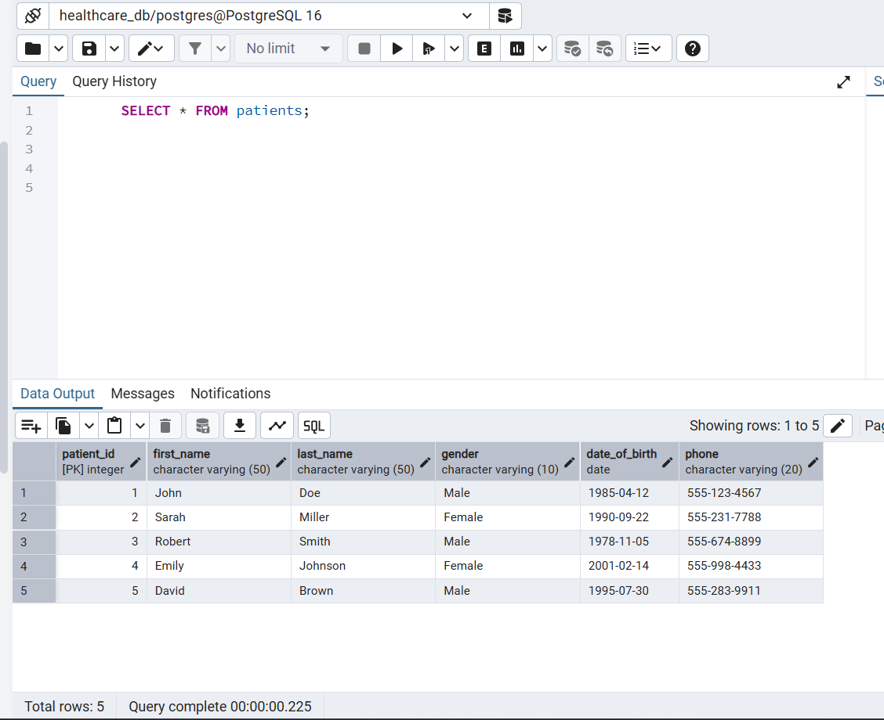
2. Get all visits with patient details
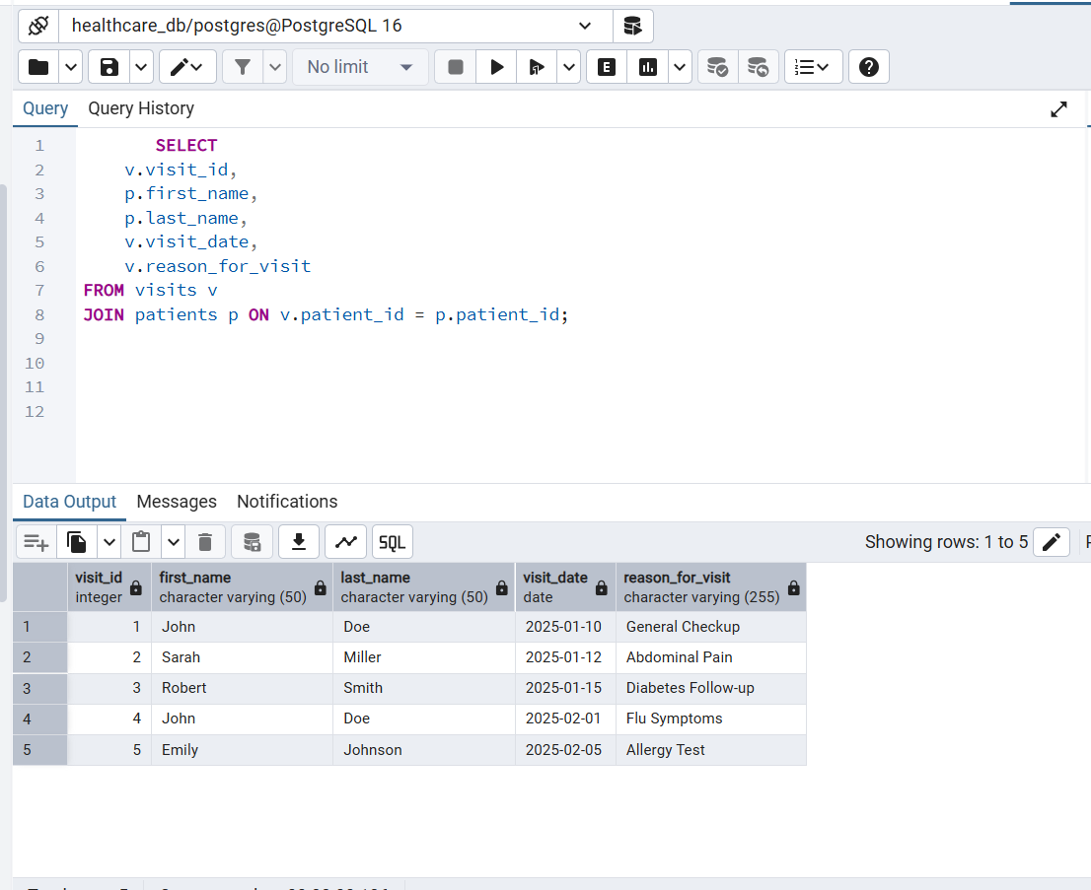
3. Find all visits in February 2025
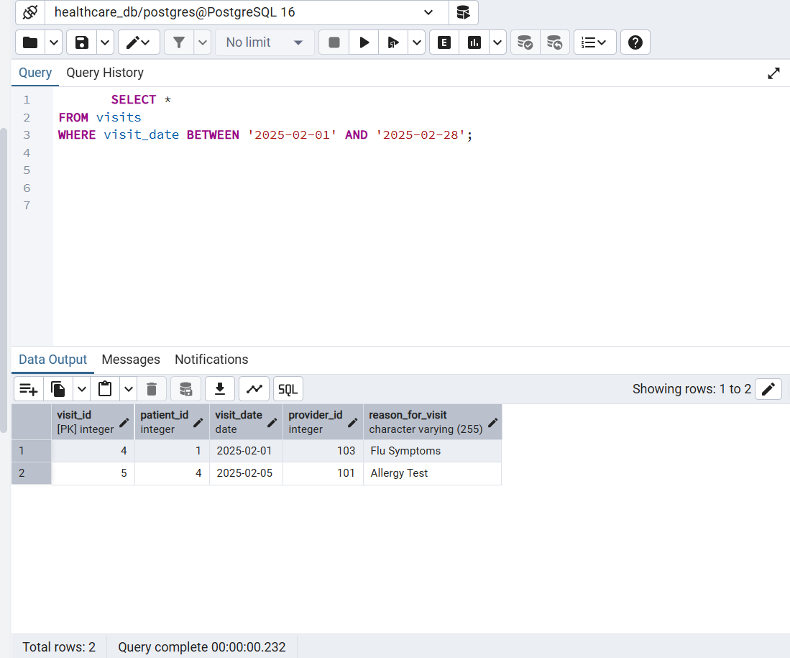
4. Find all abnormal lab results
Example: Cholesterol > 200, HbA1c > 6.5, WBC > 10
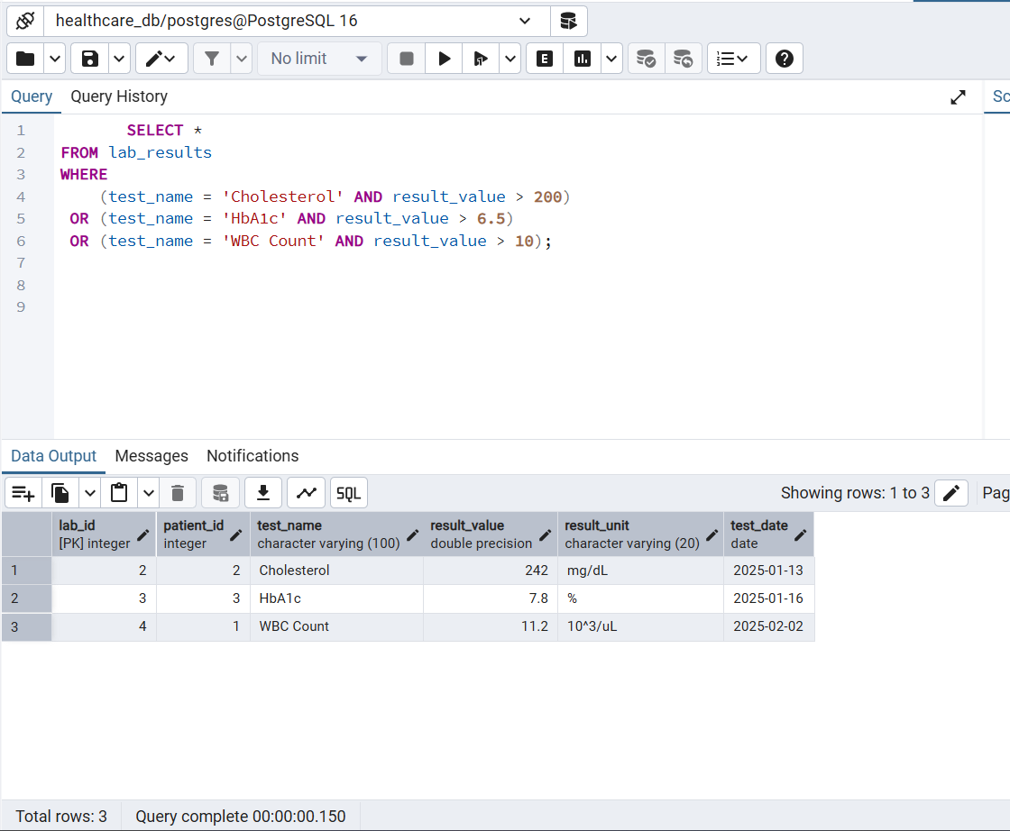
5. List all pending or denied insurance claims
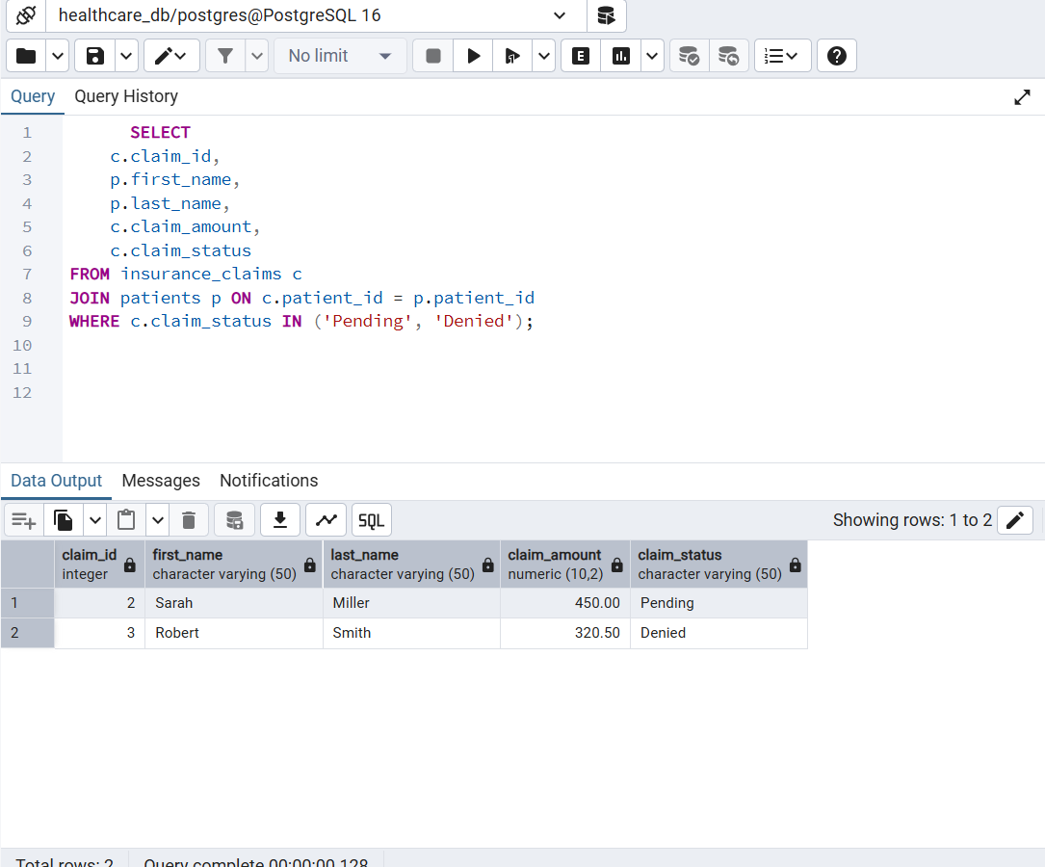
6. Calculate total claim amount by patient
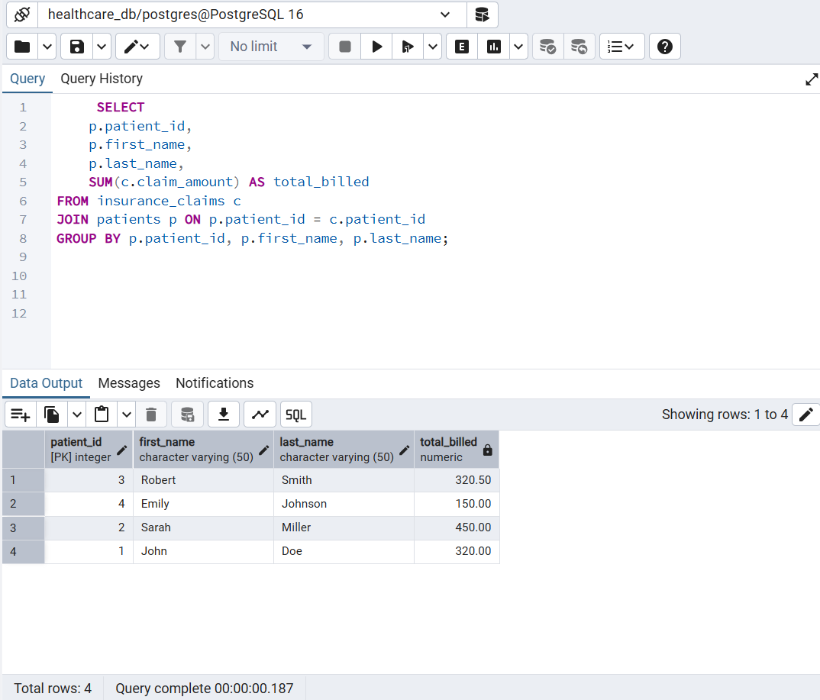
7. Count number of visits per patient
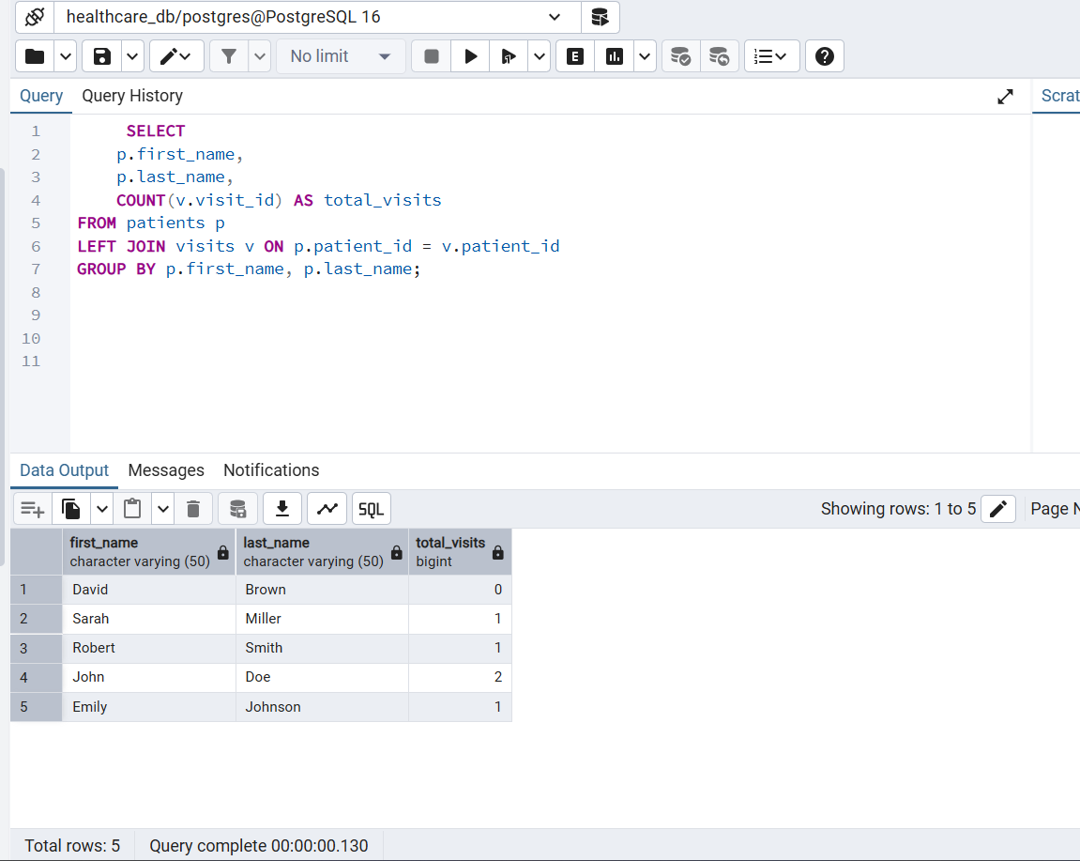
8. Get lab results for a specific patient (e.g., John Doe)
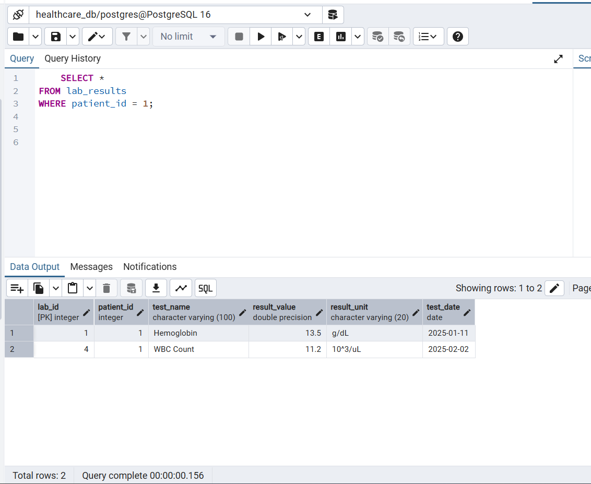
9. Extract claims that took more than 7 days to be paid
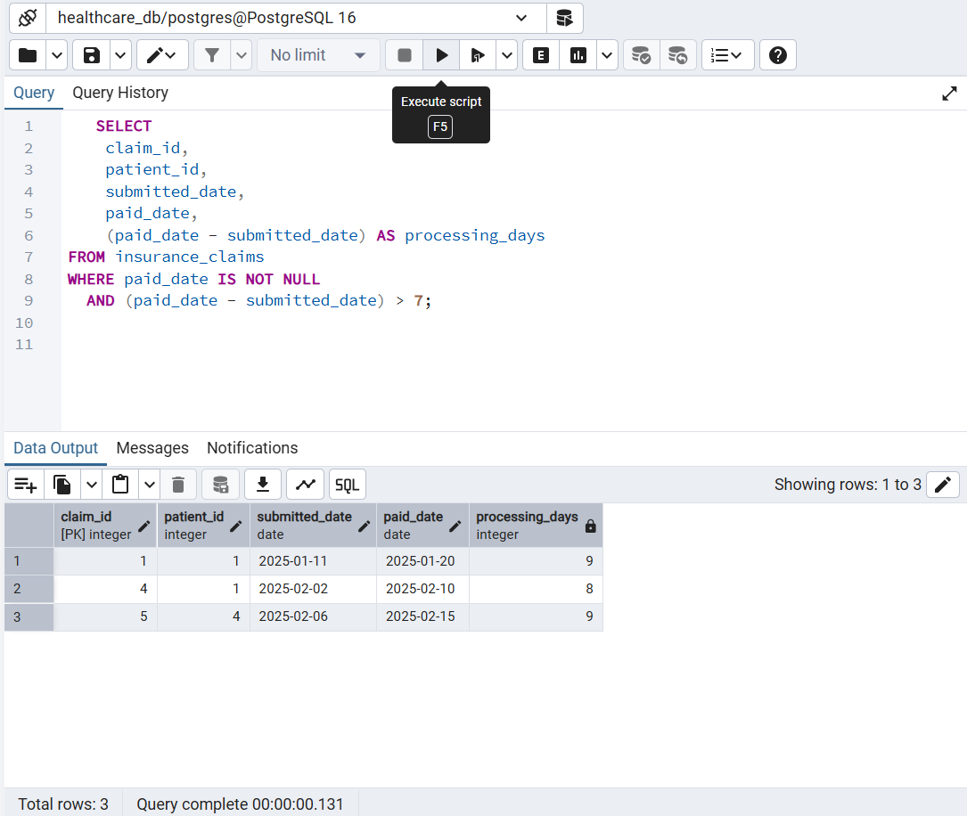
10. Join patients, visits, and claims together
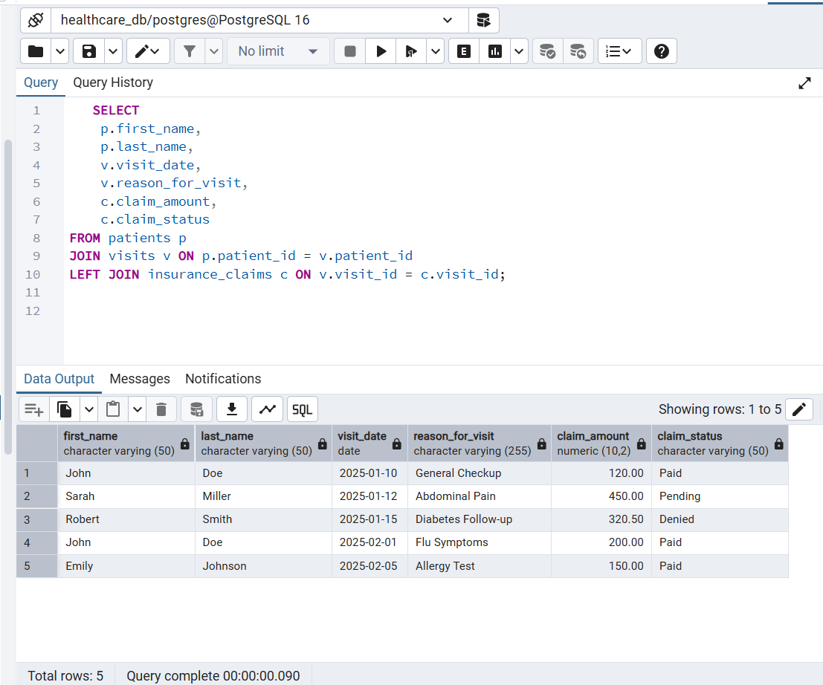
data validation SQL queries
- Check for missing patient data
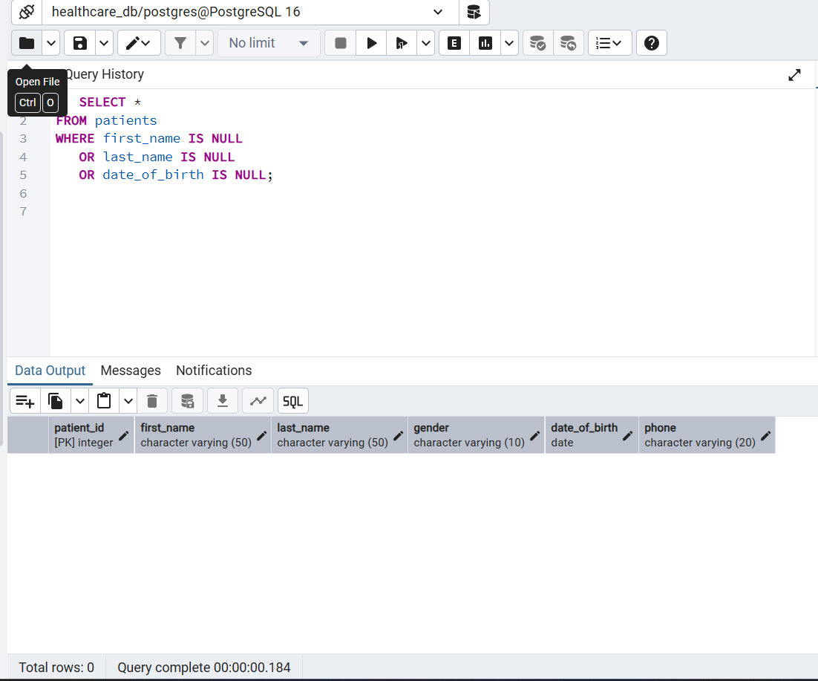
- Check for invalid dates (DOB in the future)
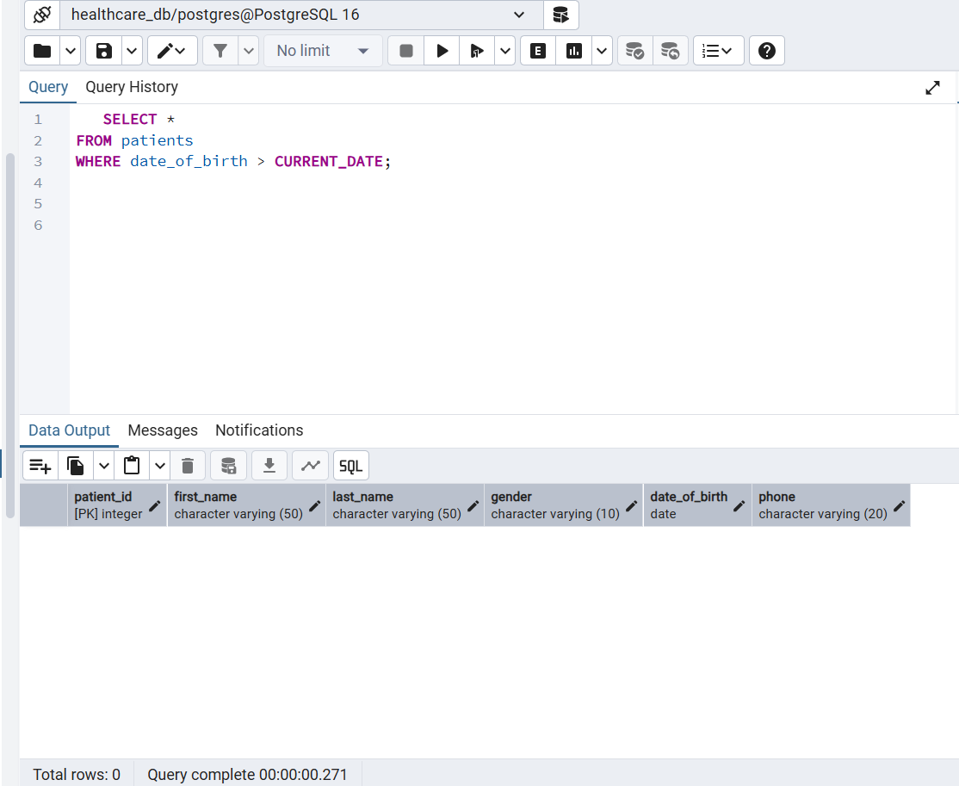
3. Check visits that refer to a non-existent patient
(Foreign key validation)
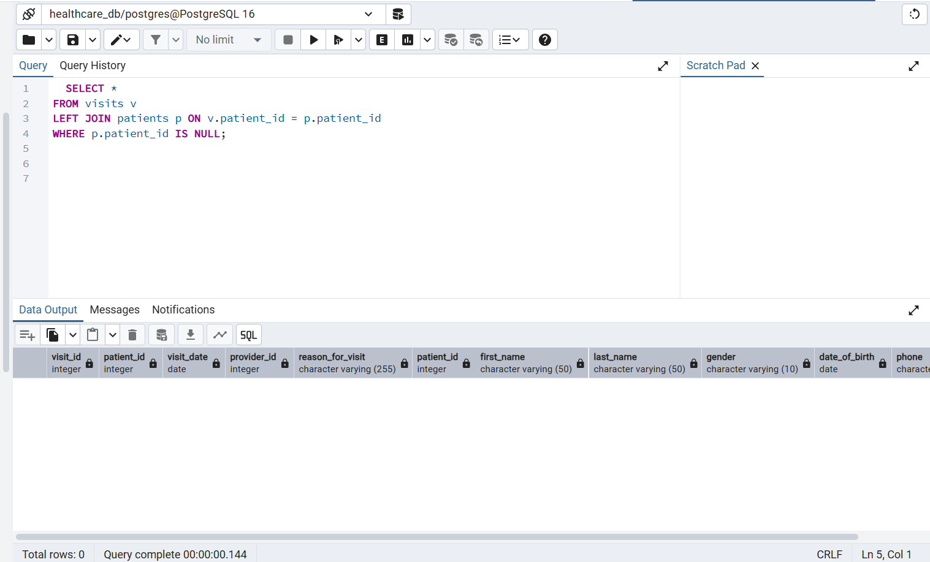
4. Find duplicate patient names
(Not truly duplicates, but suspicious)
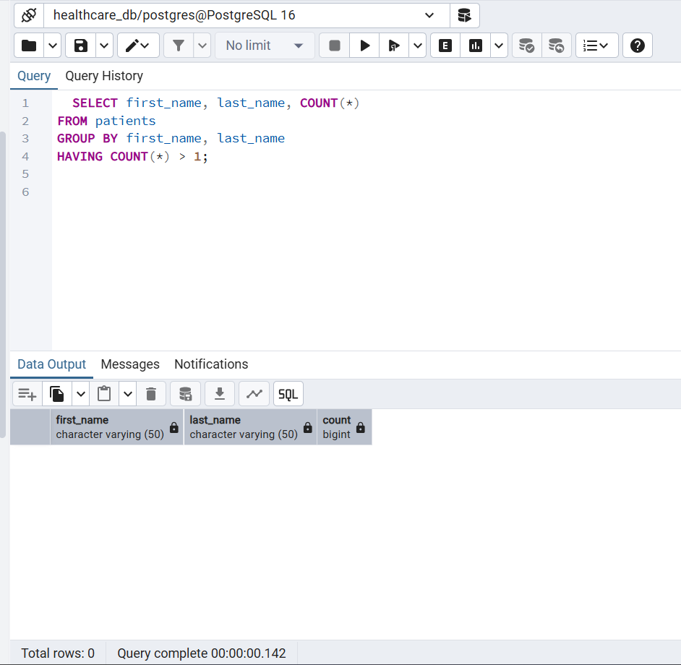
5. Check lab results with missing or invalid values
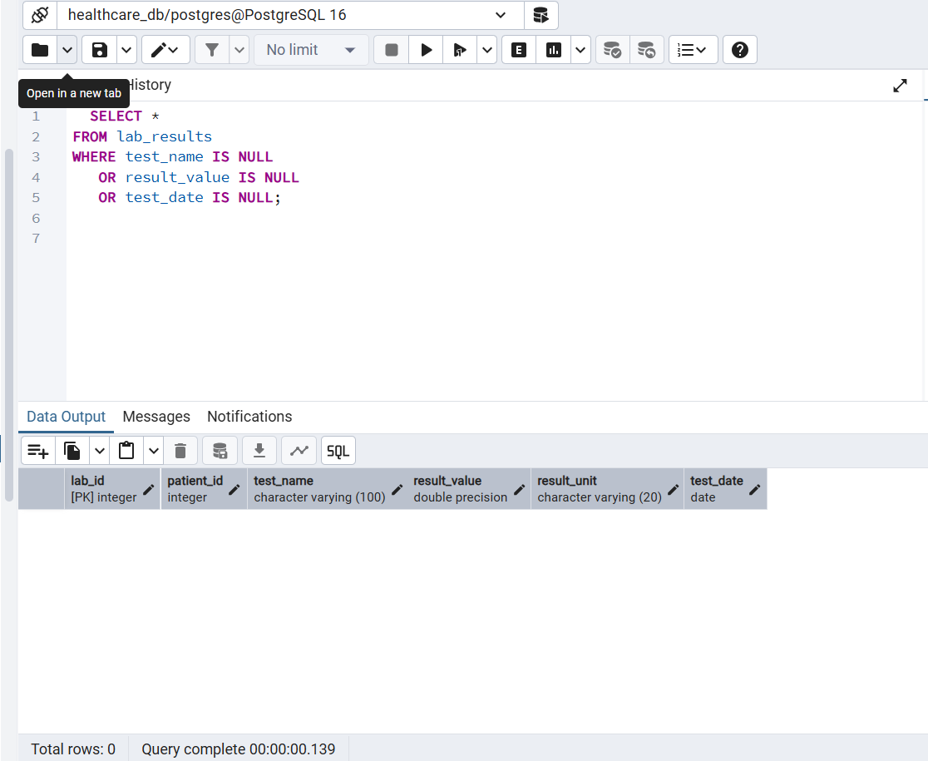
6. Identify negative claim amounts (invalid)
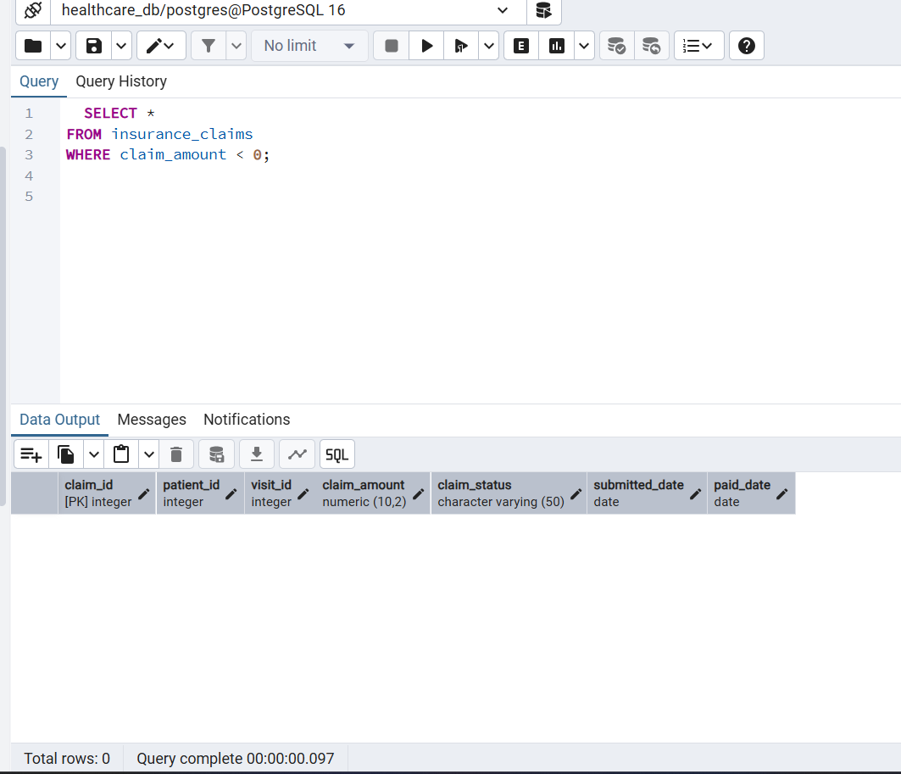
7. Claims submitted after being paid (wrong order)
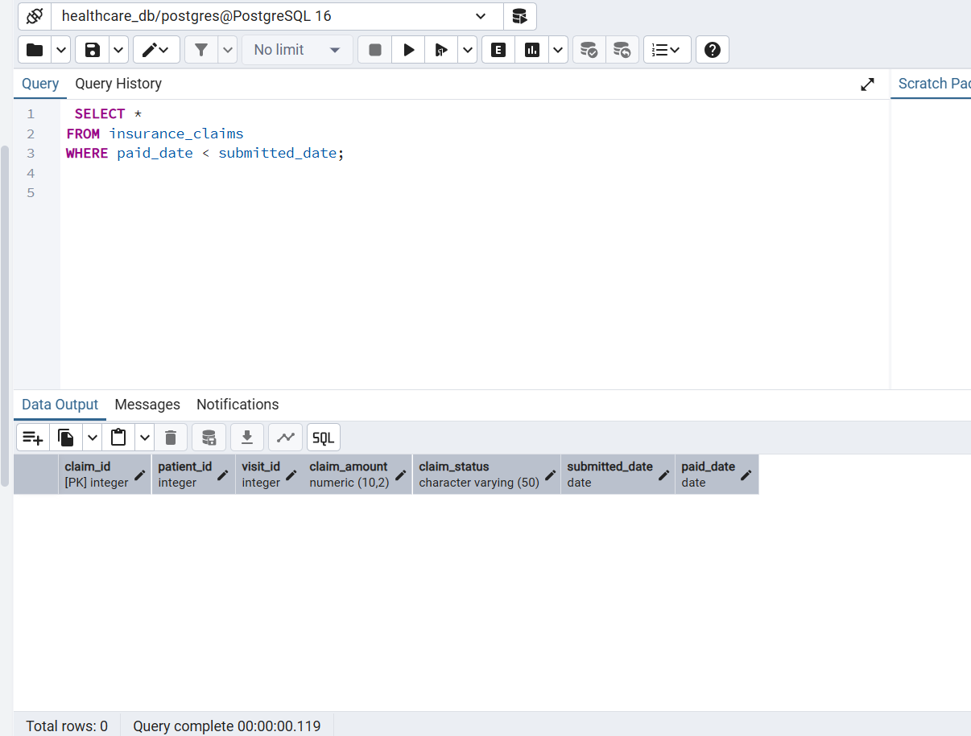
8. Claims with no matching visit
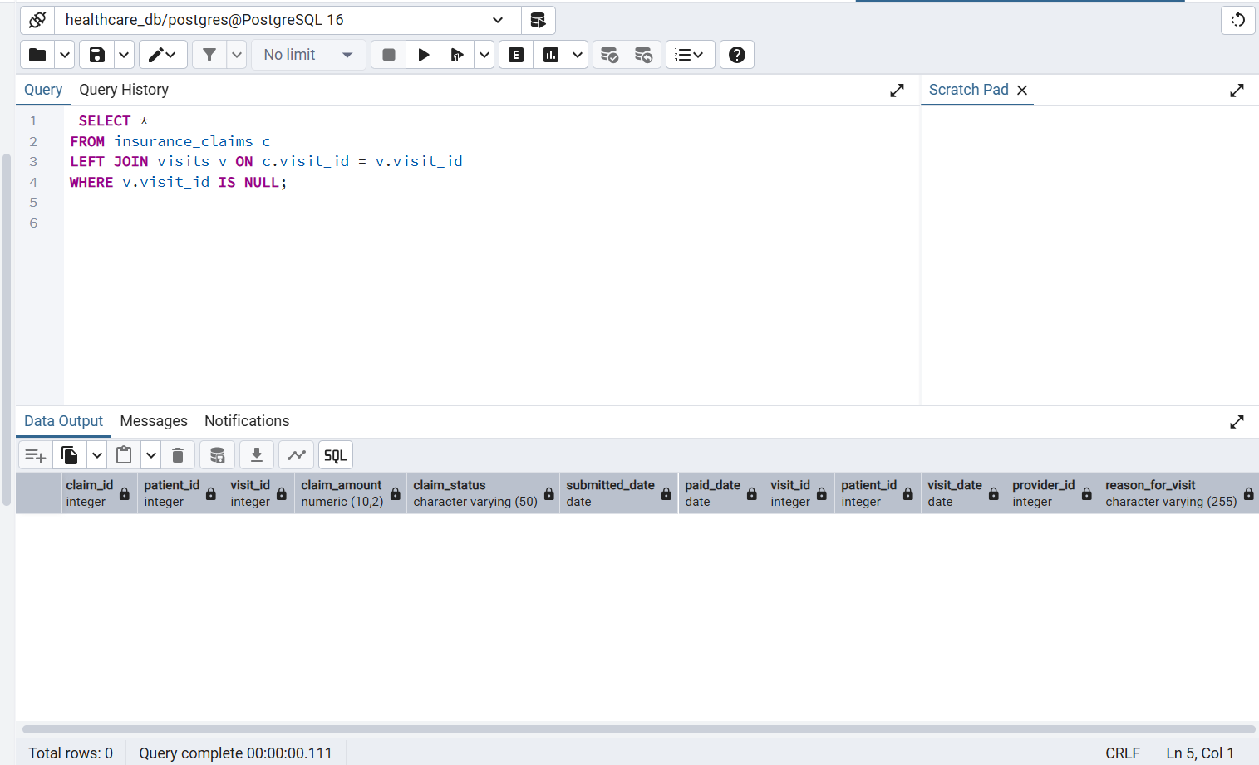
9. Visits without any reason for visit
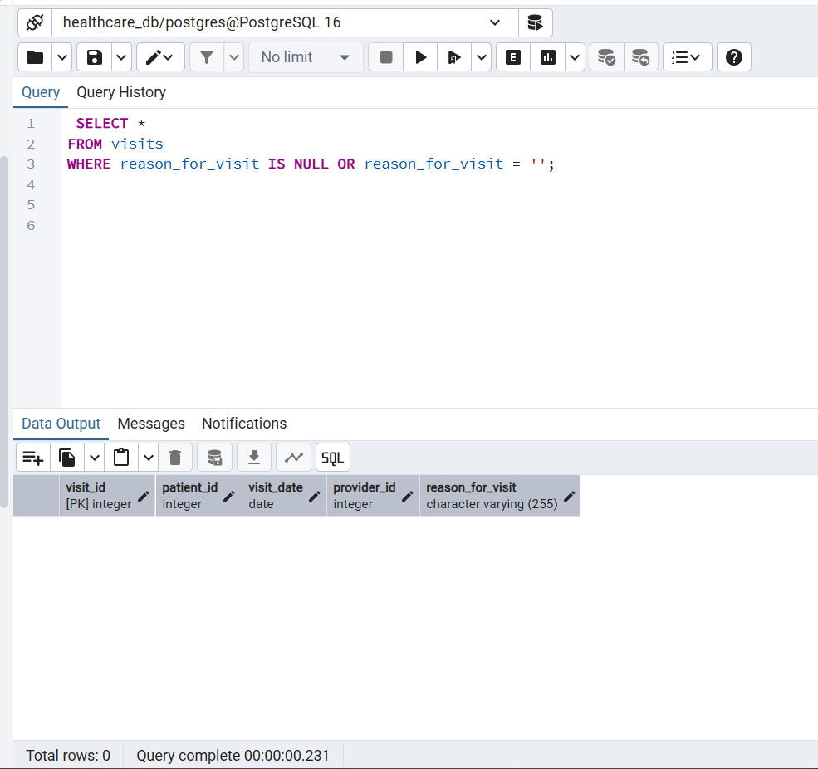
10. Patients who never had a visit
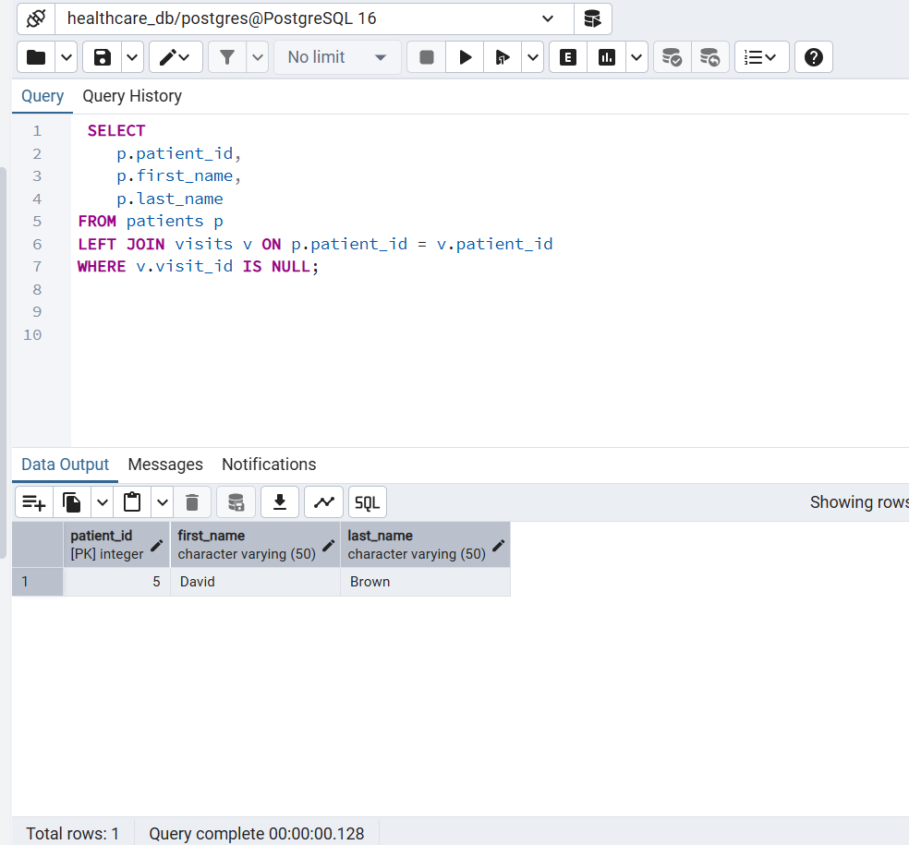
Data Quality Rules : SQL queries to calculate completeness metrics
% Patients with DOB

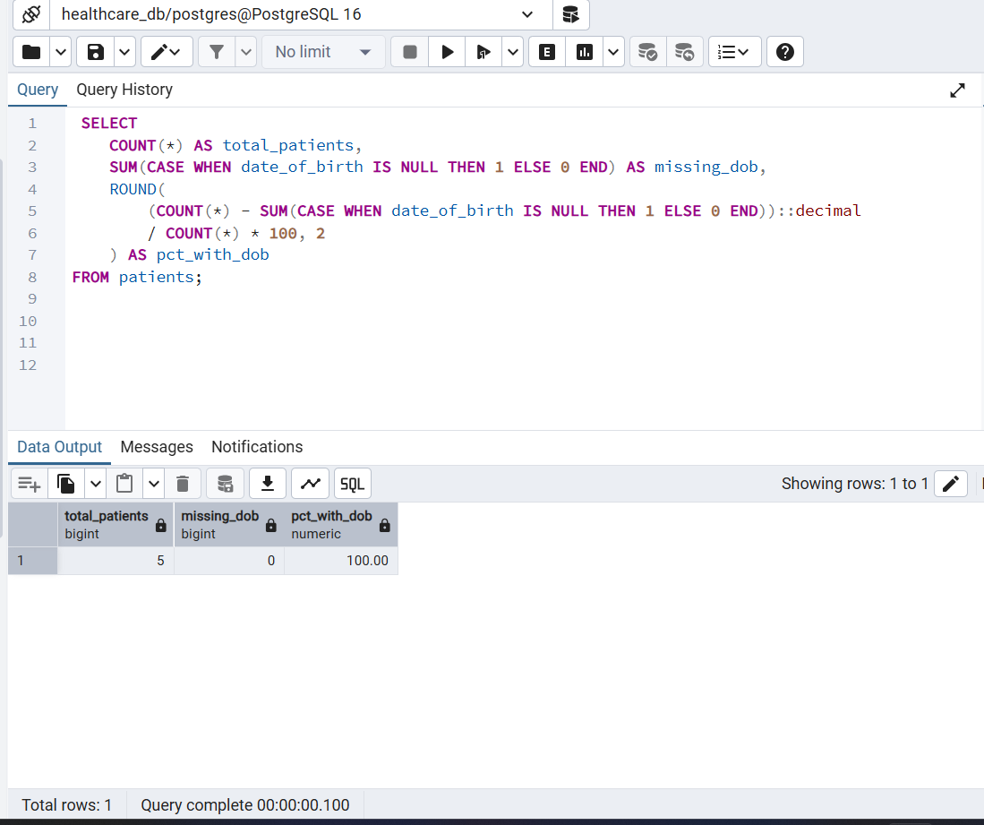
% Visits with reason
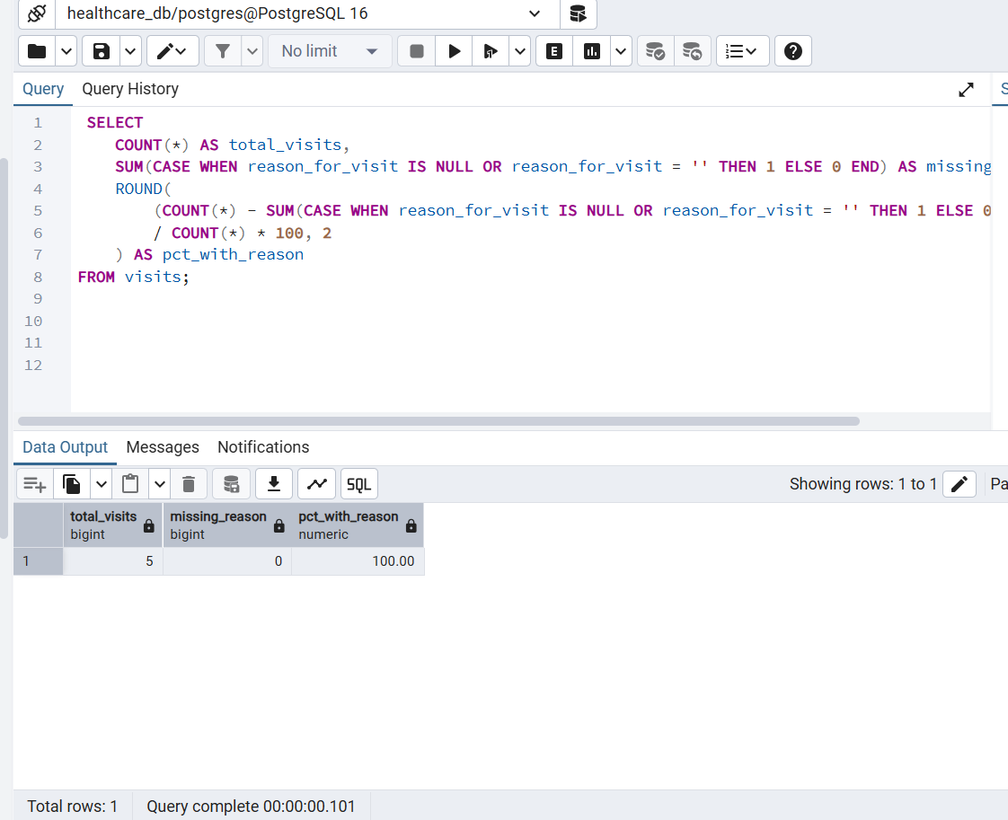

% Lab results complete

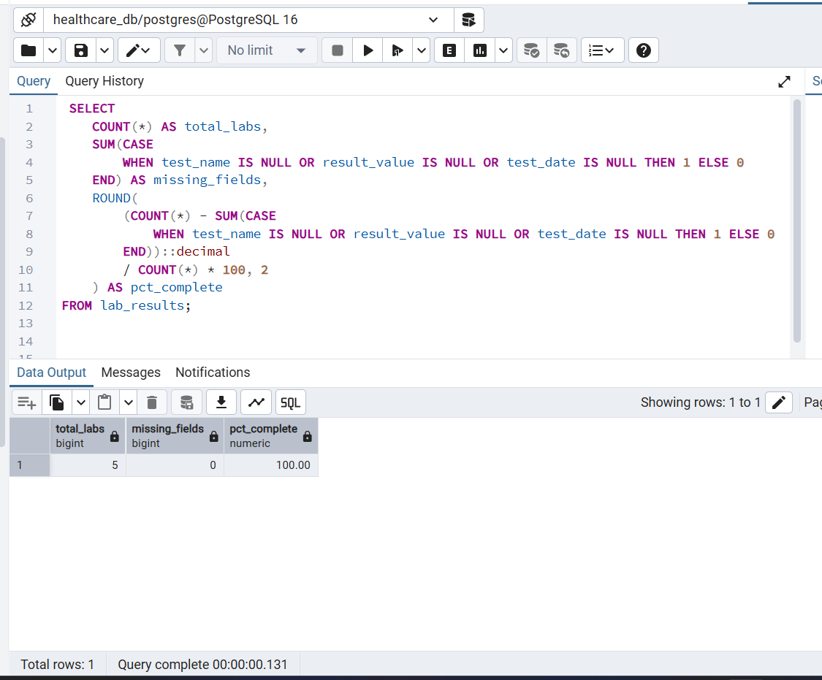

% Claims complete

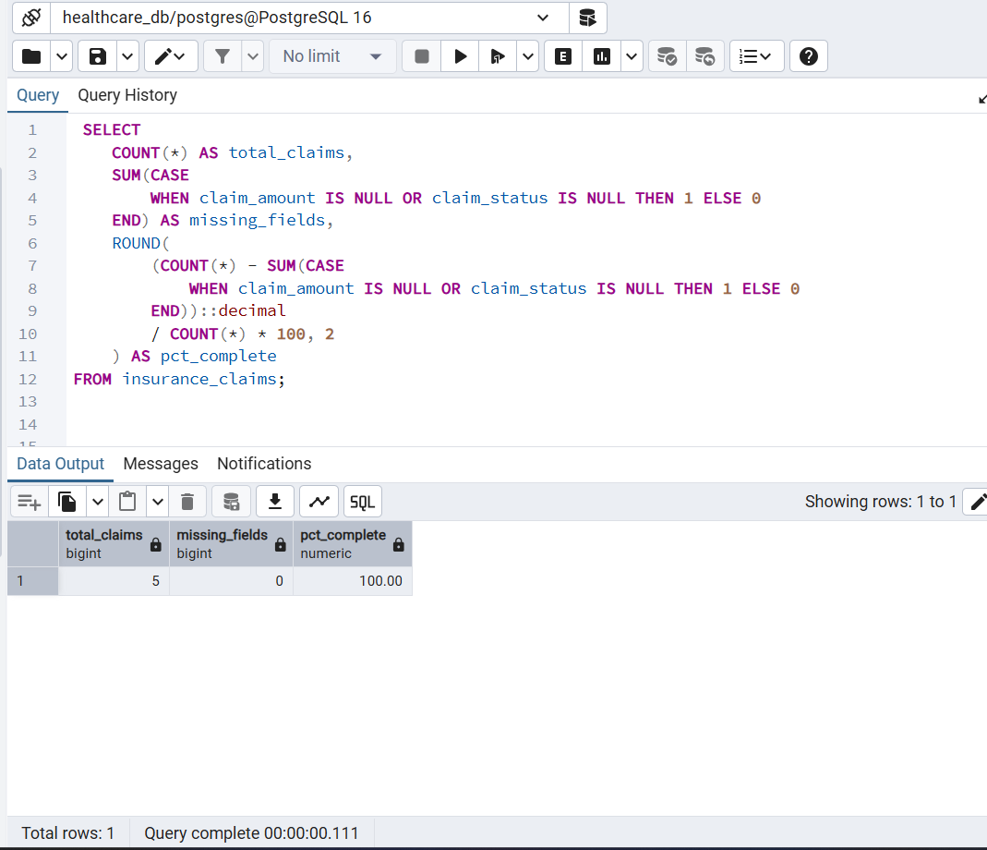

Data Evaluation & Insights SQL queries
Patients with the most visits
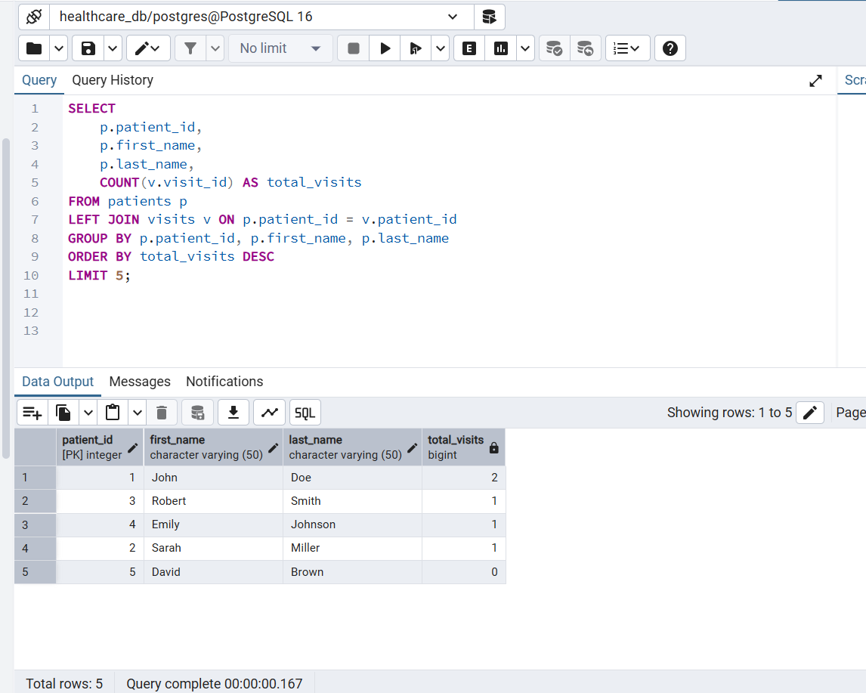
Visits per provider
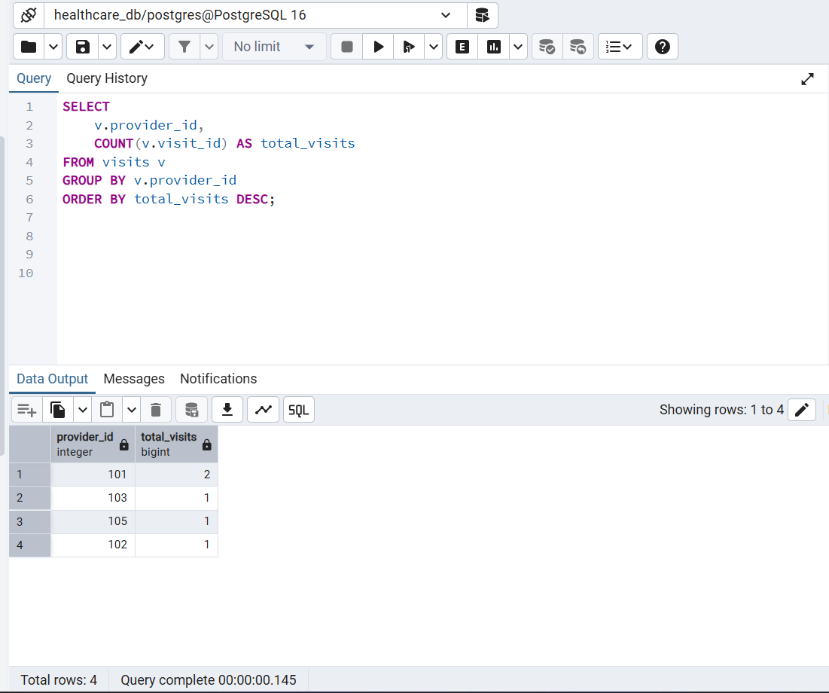
Patients with abnormal lab results
Example: Cholesterol > 200, HbA1c > 6.5, WBC > 10
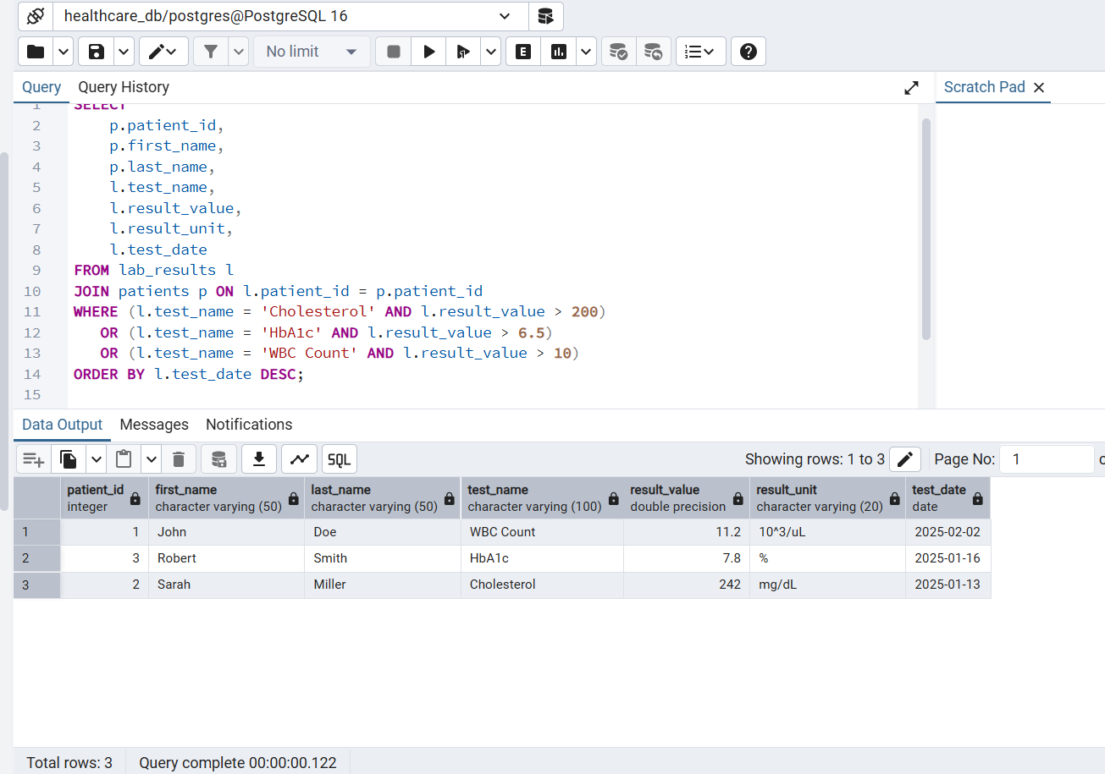

Pending or Denied insurance claims
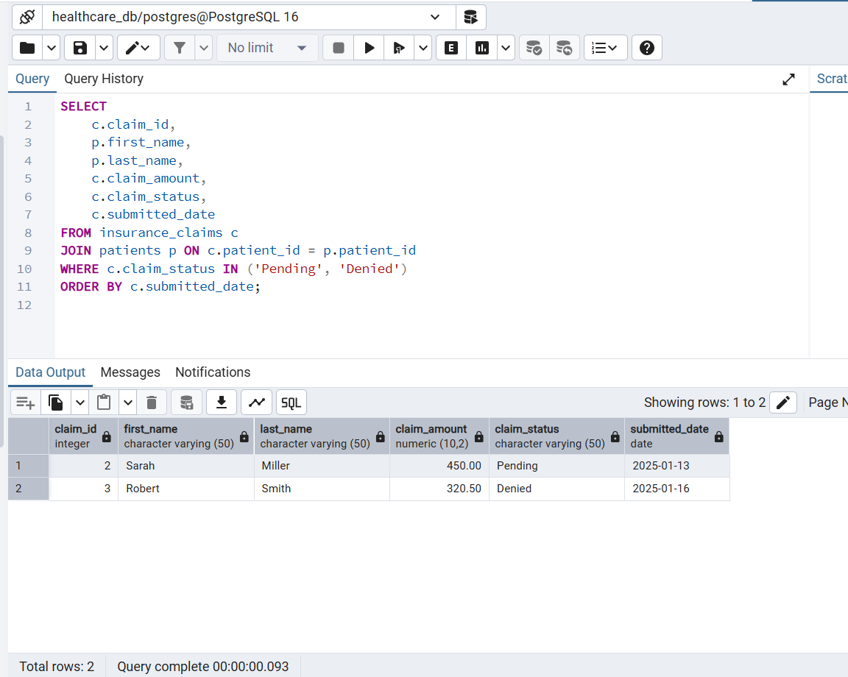

Average claim amount per patient
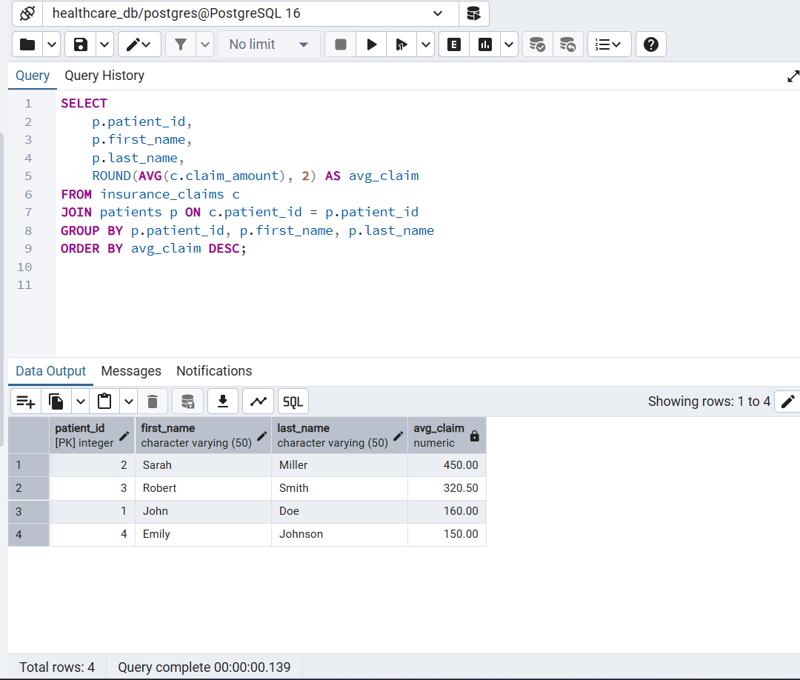
Claims processed late (>7 days)
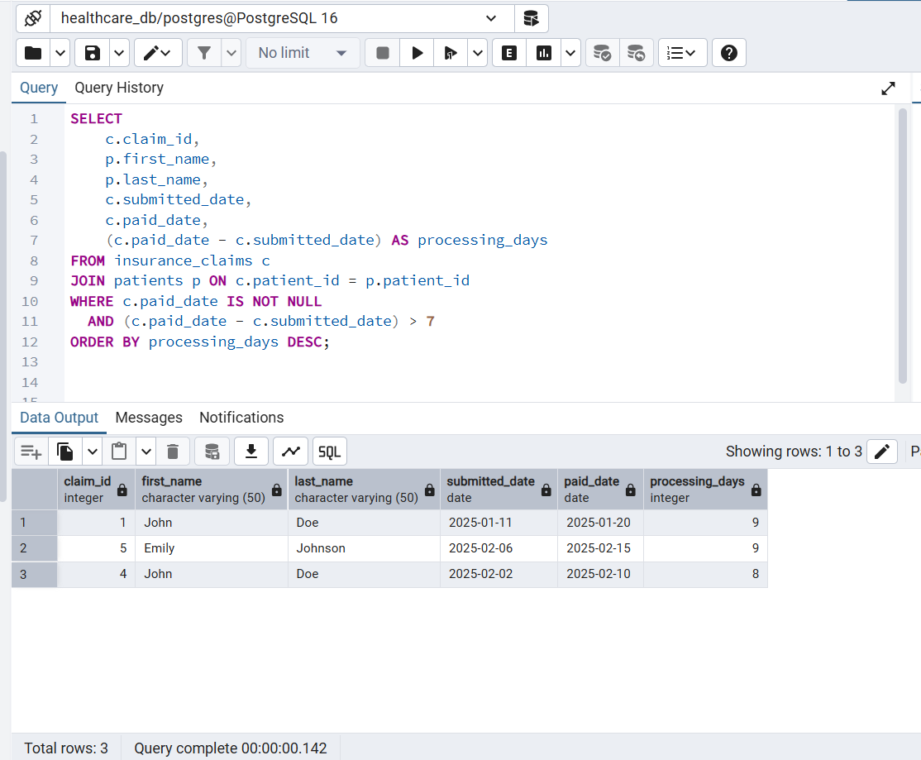

Number of visits by month

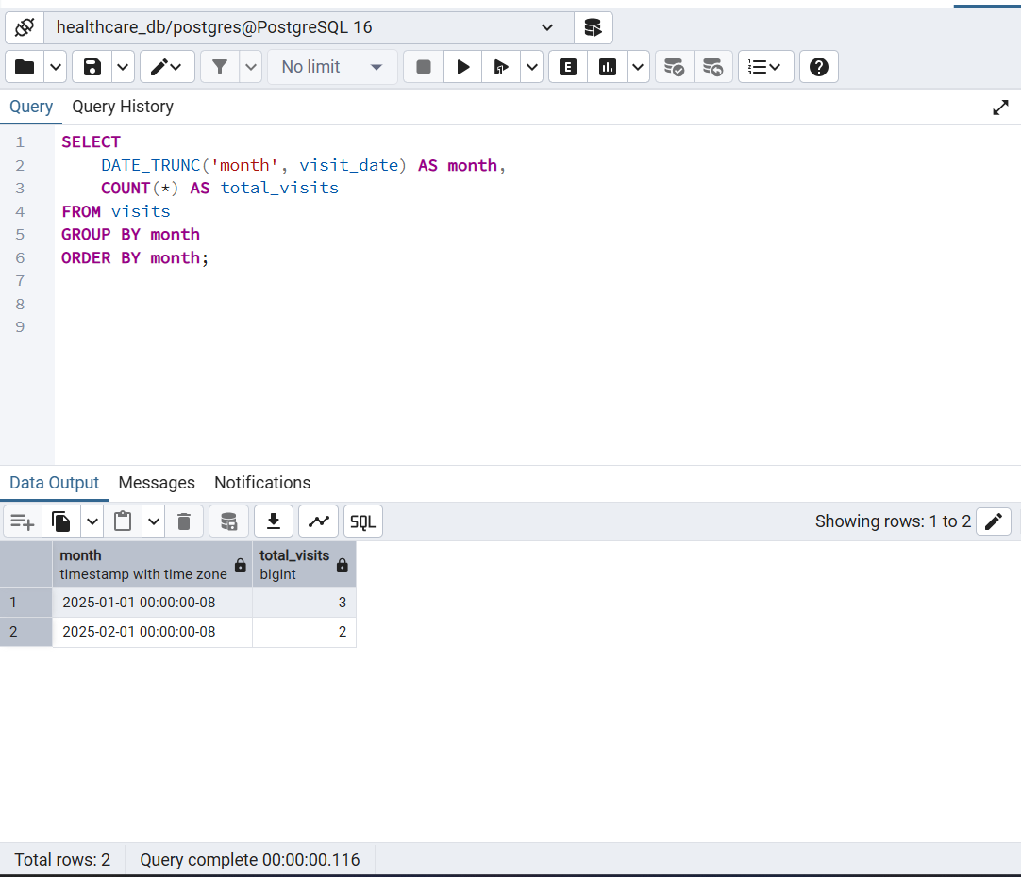
Top 5 patients with highest total claim amounts
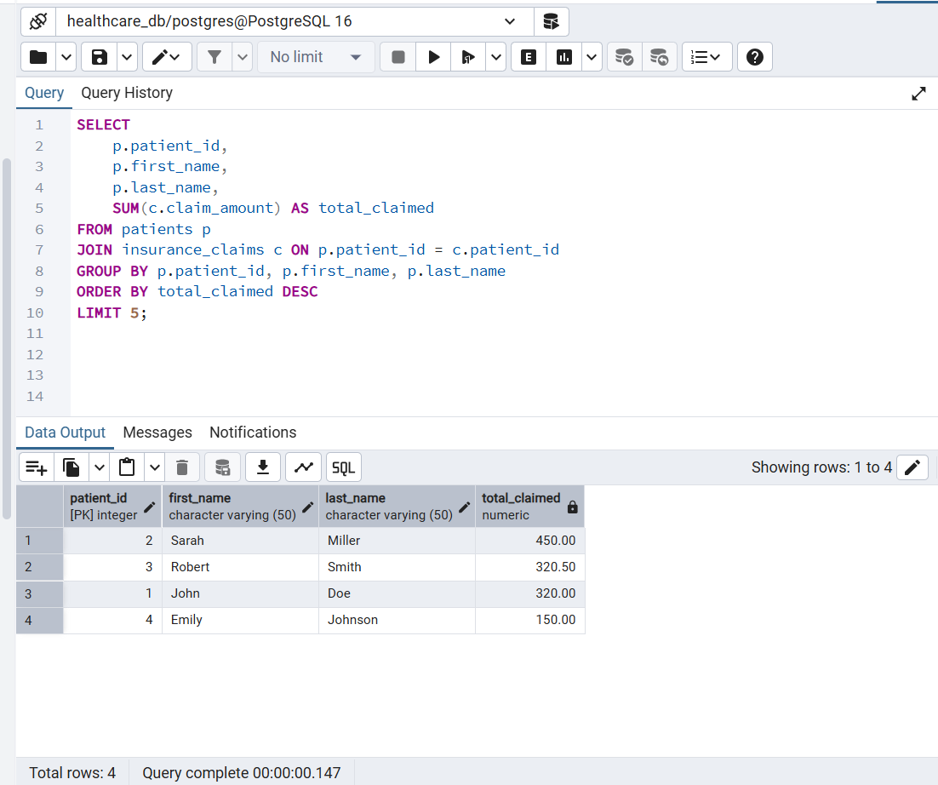

Power BI Dashboard
